A company has the customers data in csv file, The company wants to process on the file and retrieve data, please write the use cases mentioned in the below Service contract which includes the need to create a new file in the expected csv format.

**Csv stored file format**

**Home Page:**

**Insert data in CSV File >>**

**Read customer data from CSV file**

**// find all customers sorted by id**

**Sort customers by ID (Ascending)**

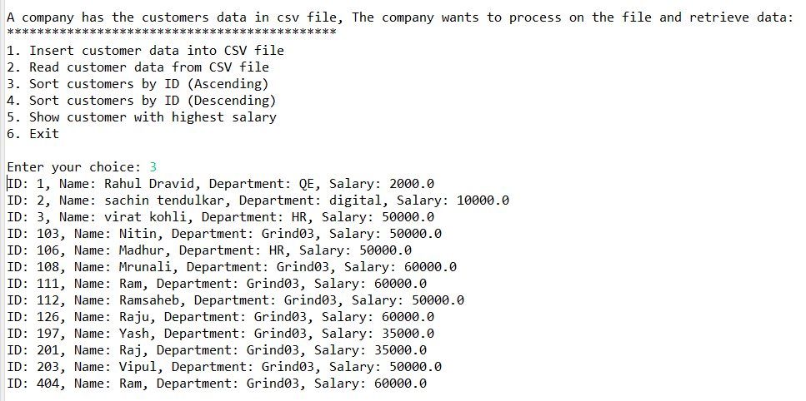

**Sort customers by ID (Descending)**

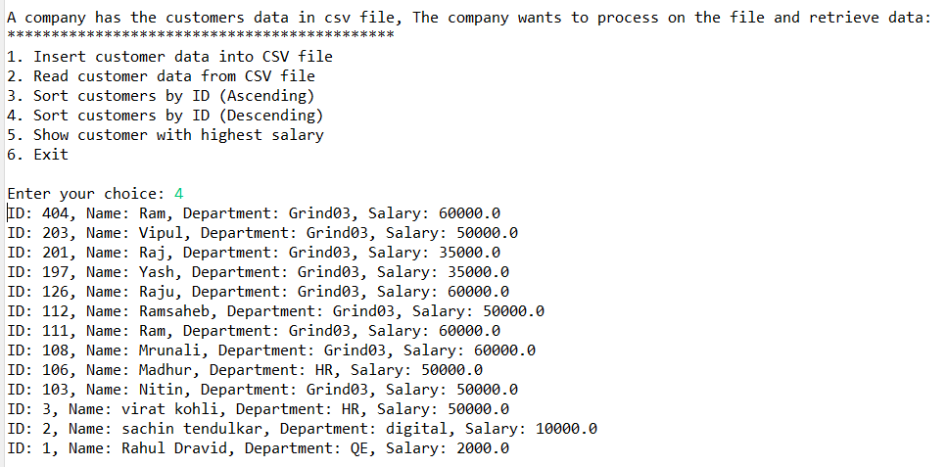

**//find customer with highest balance**

**// transformed file in the format mentioned above**

